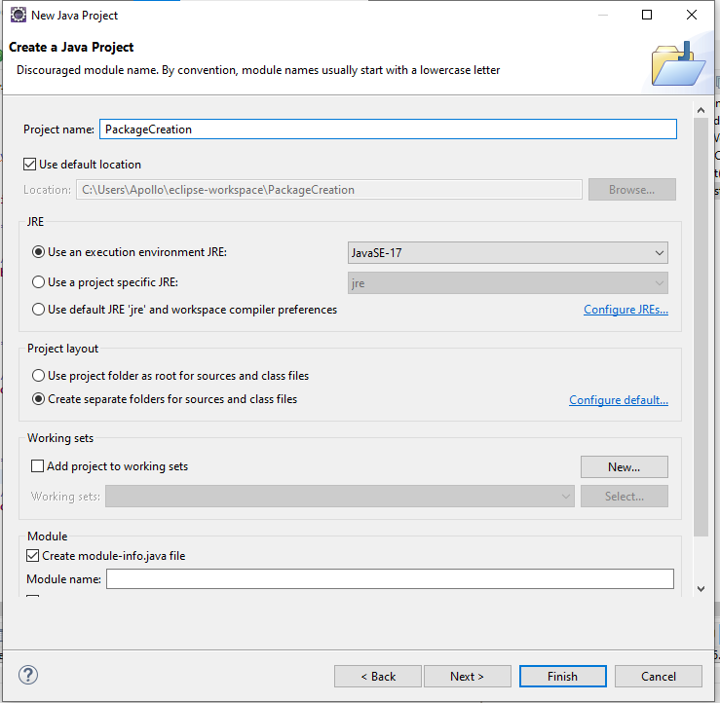

Click next

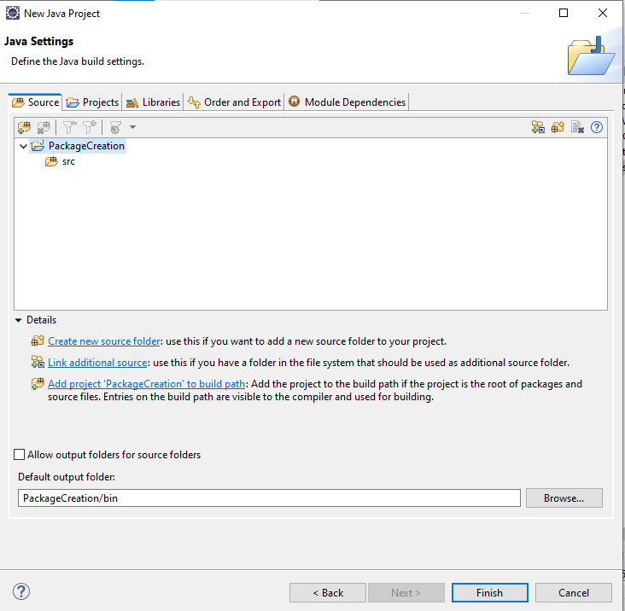

Click finish

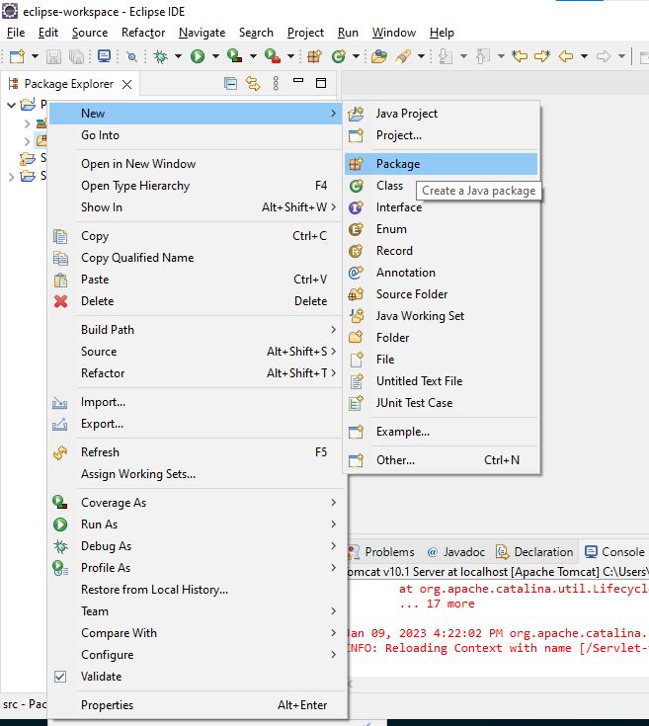

Enter Package name

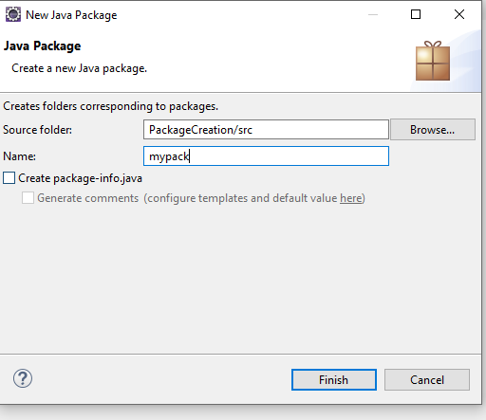

Click finish

Multiple folder creation

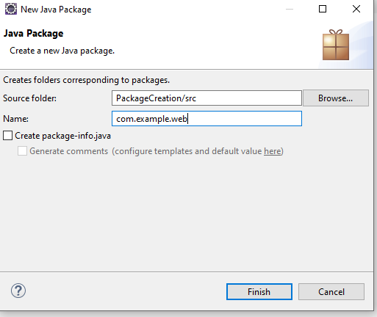

Class Creation

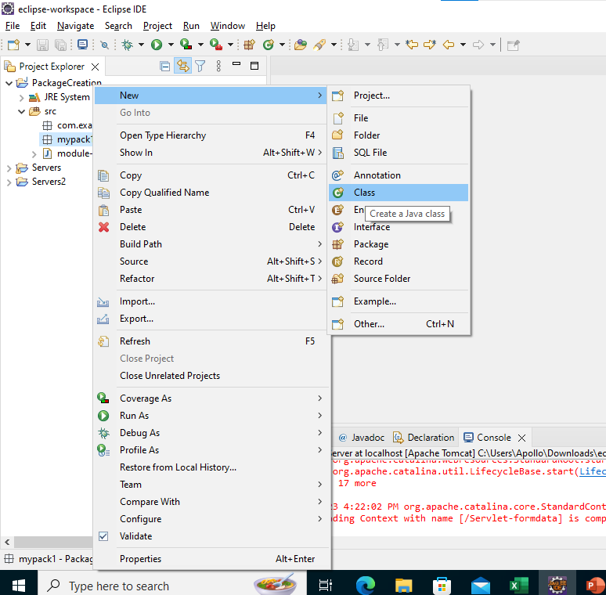

Enter name

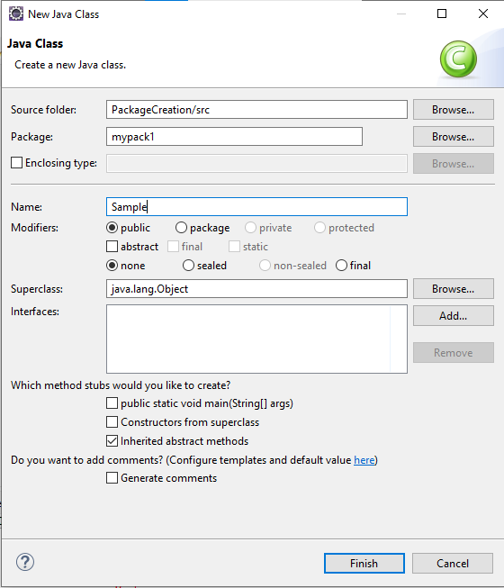

Click finish

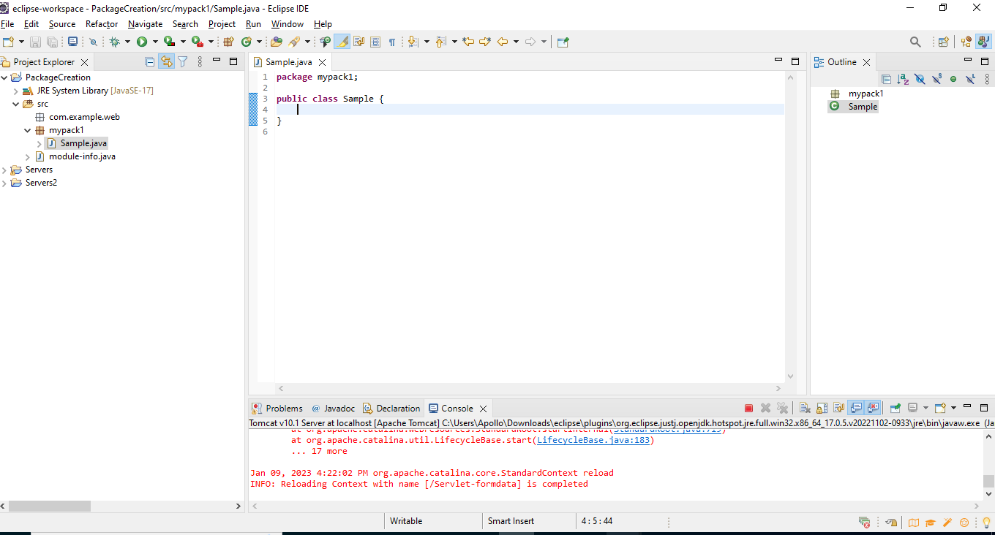

**package** mypack1;

**public** **class** Sample {

**private** **int** no;

}

We can set properties for this variable

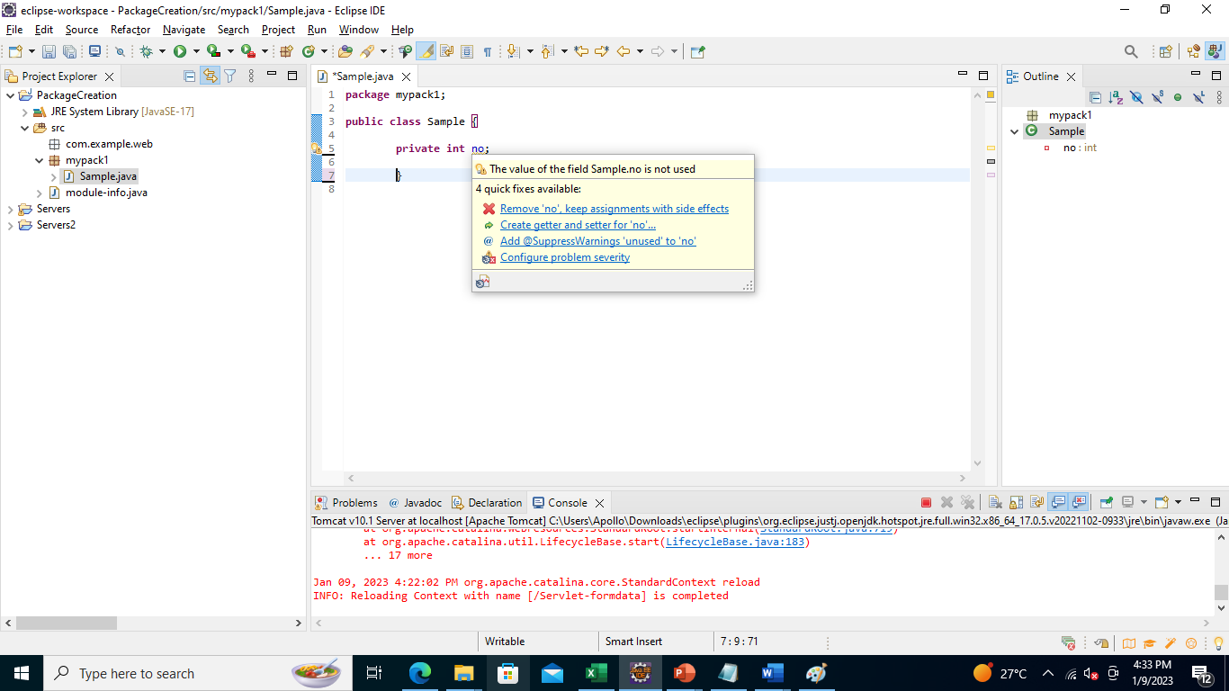

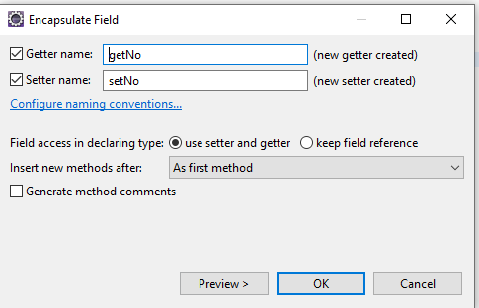

Click OK

**package** mypack1;

**public** **class** Sample {

**private** **int** no;

**public** **int** getNo() {

**return** no;

}

**public** **void** setNo(**int** no) {

**this**.no = no;

}

}

Create another package mypack2

Under create subclass inheriting from super class sample.java

Create class and in super class click brows

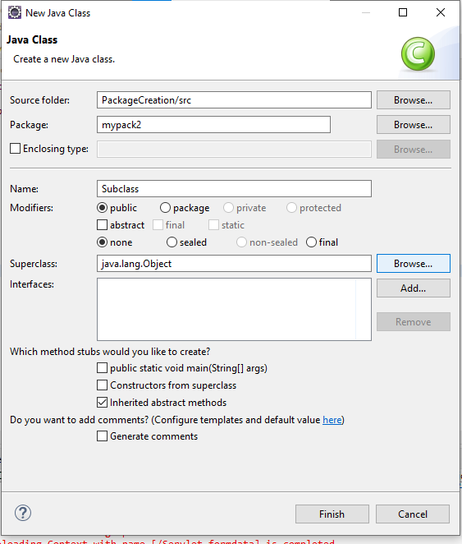

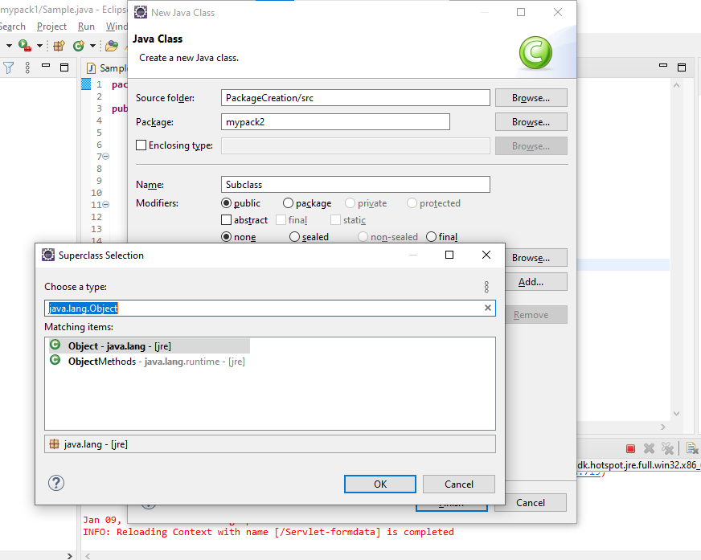

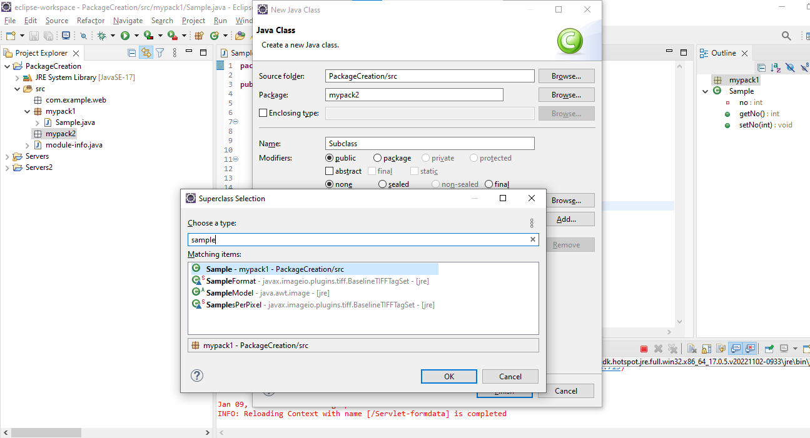

And click k

Click finish

Now subclass is created

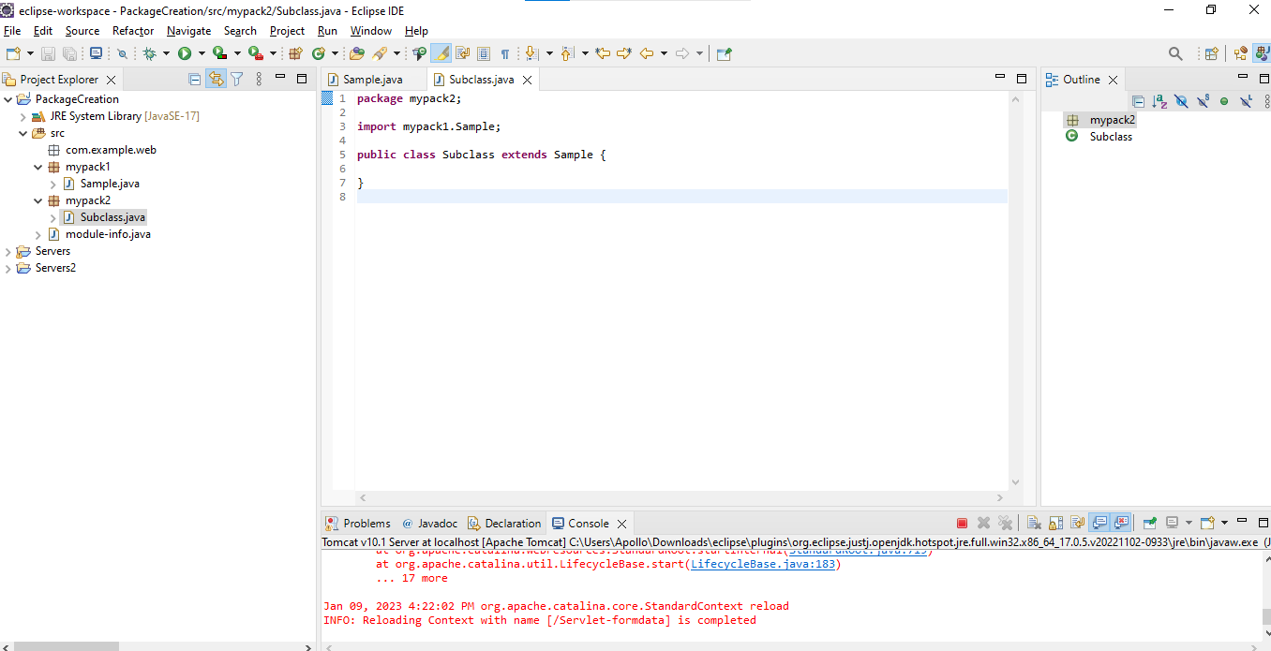

Subclass.java

**package** mypack1;

**public** **class** Sample {

**private** **int** no;

**public** **int** getNo() {

**return** no;

}

**public** **void** setNo(**int** no) {

**this**.no = no;

}

}

Next create demo.java class out side of both package in com package

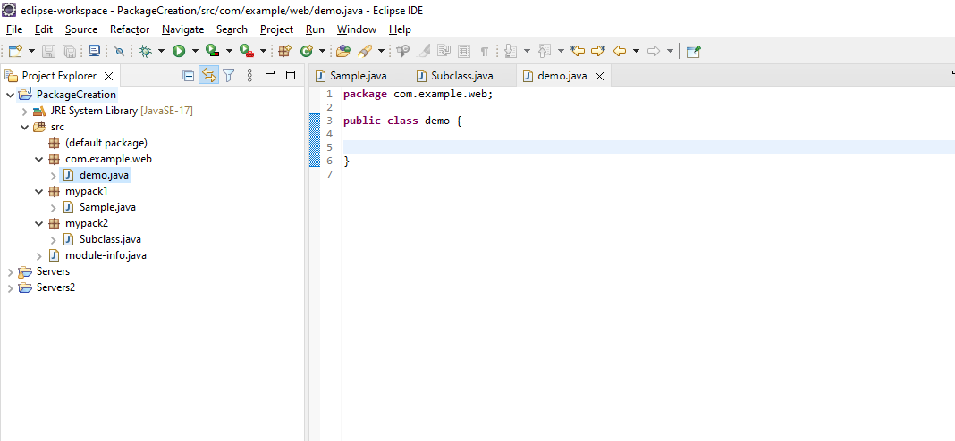

Create object for sample class from mypack1

It will not accept the class sample

We have import this class from mypack1

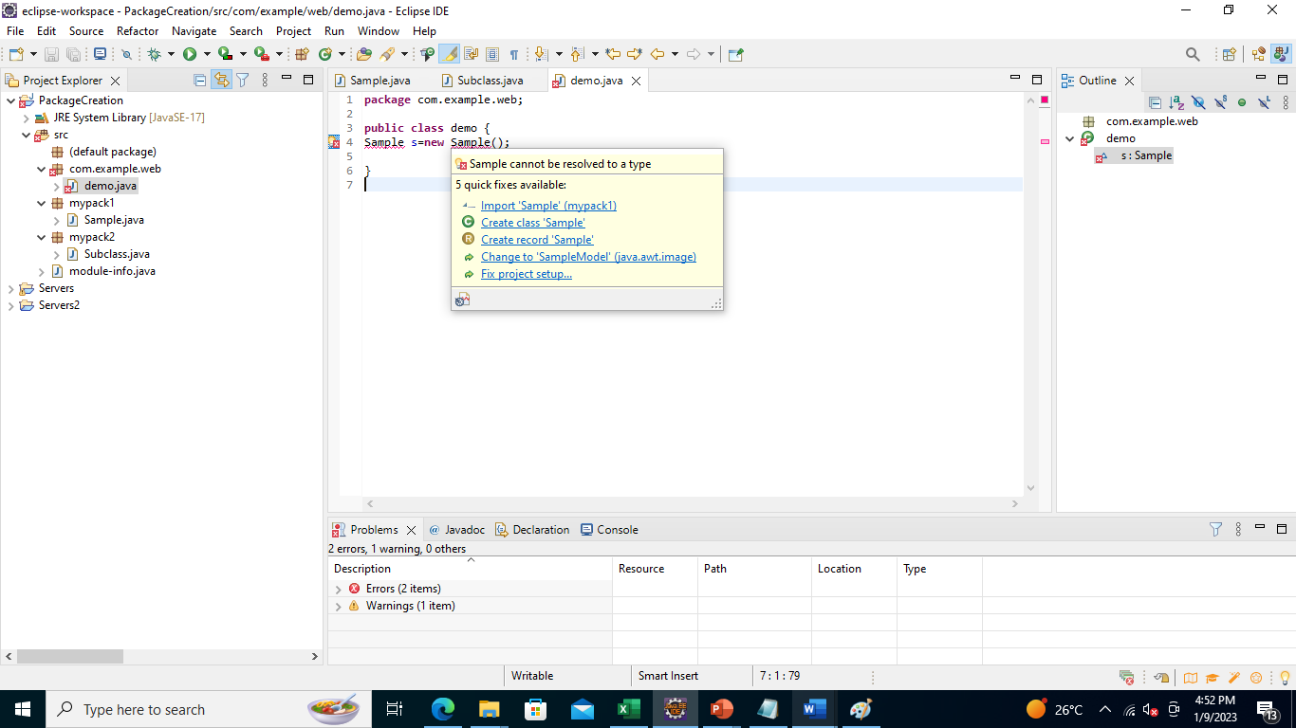

Click import option

**package** com.example.web;

**import** mypack1.Sample;

**public** **class** demo {

Sample s=**new** Sample();

}

Like that Add subclass from mypack1

**package** com.example.web;

**import** mypack1.Sample;

**import** mypack2.Subclass;

**public** **class** demo {

**public** **static** **void** main(String a[]) {

Sample s=**new** Sample();

Subclass s1=**new** Subclass();

}

}

Final code

**package** com.example.web;

**import** mypack1.Sample;

**import** mypack2.Subclass;

**public** **class** demo {

**public** **static** **void** main(String a[]) {

Sample s=**new** Sample();

Subclass s1=**new** Subclass();

s.setNo(10);

s1.setNo1(20);

**int** c = s.getNo()+s1.getNo1();

System.***out***.println("Addition="+c);

}

}

